Review of Three Modern Greek Grammar Guides
Timothy Miller
Detroit Baptist Theological Seminary

A local pastor recently asked me to recommend a reliable Greek guide for working through a New Testament text. He was planning to preach through the text, and while he had plenty of commentaries, even commentaries based on the Greek text, he was looking for something that engaged the Greek more directly. I was thrilled not only that a pastor wanted to stay engaged with the Greek language, but also because I could recommend more than one resource! Indeed, the pastor’s question led me to look closely at three modern series designed to aid readers in engaging with the Greek text, and this review essay is the fruit of that study.
Three Greek guides will be reviewed below. First, the Exegetical Summary (ES) series, produced by the Summer Institute of Linguistics, began in 1989. Only two books are yet to be completed for the New Testament (John and Acts). Second, the Exegetical Guide to the Greek New Testament (EGGNT) produced its first volume in 1991, but the series was recast under a different publisher in 2010. Since then, nine additional volumes have appeared. Finally, the Baylor Handbook on the Greek New Testament (BHGNT) series started in 2003. And while it started slow, the series now has covered twenty New Testament works.
Each of the series has been written with a distinctive purpose, goal, and reader in view. Therefore, this paper will review each series, identifying who the series is designed for, what the stated purposes are, and how the book is structured to accomplish those goals. After each review, I will summarize the strengths of each, along with their weaknesses. Finally, I will provide a comprehensive comparison in the conclusion.

Exegetical Summary Series
The Summer Institute of Linguistics is a faith-based organization which is broadly concerned with the study of human language for the purpose of Bible translation. Their Exegetical Summary series was produced primarily for translators, but is also aimed at assisting students in the translation process. Unlike the other guides we will consider below, this series does not offer conclusions. Instead, the chief aim is to identify and highlight areas where translators may disagree. In the standard preface in each volume, the editors note that “before translating a passage, a translator needs to know exactly where there is a problem and what the exegetical options are.” The purpose of the series is not to provide the answer to the problems; rather, it is to make the reader aware of the major exegetical questions. And while answers are presented, these “questions are answered by summarizing how scholars have exegeted the text.”

Book Structure
Books in this series begin with a general Series Introduction, which explains the purpose of the work, its structure, and how it can best be used. Because these books are not designed to replace commentaries, there is no introduction to the biblical book. Instead, after the abbreviations and bibliography, the author of the work begins analyzing the Greek text. Because of the nature of the work as a reference tool, pointing readers to other resources, the abbreviation page is substantive and will be accessed frequently.
The meat of the work is the analysis of the Greek text. Each section begins with a discussion of discourse units (see, Figure 1), describing how various commentaries and translations have divided the passage. As we will discover, this is a unique element of this series, as no other Greek guide directly focuses attention on discourse units. Following each suggested discourse unit, there is an alphabetized list of resources that assume or argue for that unit. The list starts with commentaries and then, following a semi-colon, lists Bible versions.
Figure 1: Discourse Units
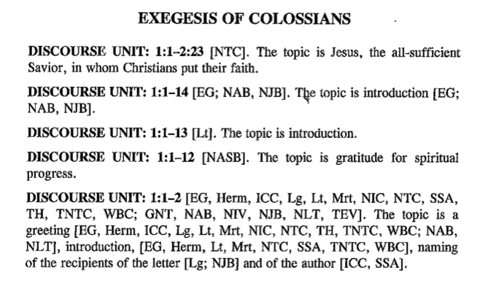
After showing the proposed discourse units, the author considers the text verse by verse, breaking each verse into its major phrases. These phrases are presented as boldfaced, translated clauses in English (see, Figure 2). The preface indicates that the translation provided is a “semi-literal” translation, which seeks to bring out the translational challenges of the Greek. Where more than one English word translates a Greek word, the English words are joined together by hyphens (e.g., he-said for λεγει).
Figure 2: Analysis of the Text
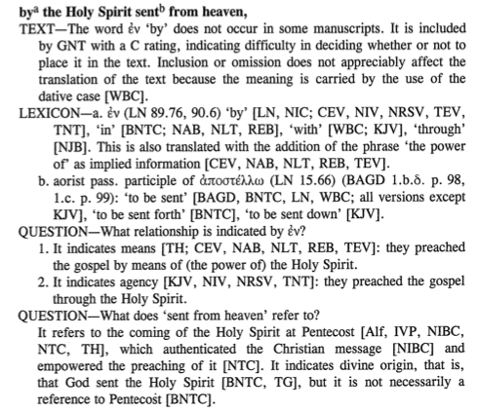
Three sections may appear below each phrase. First, if there are any textual issues, those are considered under the Text section. If the variant affects translation, the author highlights how various Greek versions, commentaries, and translations have decided on the issue. Second, the author considers lexical matters in the Lexicon section. By means of raised lower-case letters in the translation (e.g., ^{a, b}), the author highlights which Greek word(s) will be considered. The lexical form of the words is produced in Greek along with where the word is found in Louw and Nida’s lexicon and BAGD. The various English translations of the Greek word are considered next, highlighting which resources take which position, sometimes providing the resource’s explanation for the choice. The exegetical options are generally presented in descending order of popularity.
Finally, the Question section is where the author considers a multitude of contextual, grammatical, syntactical, and semantic issues. These questions are sourced out of translational differences, and thus are framed to allow the reader to see potential exegetical options. As with the prior sections, the author provides the exegetical options and identifies how the commentaries and translations have decided on these questions.

Critique
This series has the distinction of being the oldest of the Greek grammar guides we are considering in this review. As such, it was produced to meet a felt need, not to compete with other products. The chief aim of this series is to show the reader, primarily conceived of as the translator, the variety of exegetical options as mined from the most influential grammars, commentaries, and translations. And any objective observer must admit that the series soundly accomplishes this goal. At a glance, a reader is able to see where exegetical challenges are in a text, and he can see what a broad consensus is, or even whether there is one.
Despite being written for translators, the editors rightly recognized that the series is also quite helpful to students of Greek. The chief aid for Greek learners is the Question section, which helps newer Greek students recognize the questions they should be asking of the text. Often novice Greek students, not aware of the ambiguity or flexibility of certain Greek elements, may overlook areas of controversy. This series directs the reader’s attention to those controversies. By working through multiple volumes of this series, a student will begin to see patterns and gain an awareness of where closer attention should be given to a text.
Some readers may be frustrated by the lack of conclusions in the book. But this perceived weakness is the book’s greatest strength. Indeed, the lack of conclusions is by design, for according to the preface, “this book does not replace the commentaries it summarizes.” By leaving exegetical options open, the book requires the reader to do his own homework. And by providing extensive references, the book guides the reader to where he may find answers.
One potential problem with the series concerns how a reader may misuse the volumes. If a reader merely counts noses, seeing which interpretation or exegetical option is most popular, he is abusing the material. While it may be important to know that the majority take a particular position, popularity does not determine truth. In the end, the nature of these volumes makes such a use possible, but the editors have done a fair job guiding the reader away from such use. For example, the preface directs the reader to engage four commentaries when using these works.
A few negatives should be mentioned about the series. First, it would be nice to have a brief biography concerning the author of the work. Second, in 2008 many of the volumes previously published were reprinted in a second edition, but it does not appear the content was updated. For instance, the 1 Peter volume was originally published in 1998 with a second edition printed in 2008. Nevertheless, no commentary after 1992 is included. Paul Achtemeier, John Elliott, Karen Jobes, and Thomas Schreiner have all produced important works in the interval between 1998 and 2008, yet none of their works are included. This criticism is significant, because many will engage these resources as a tool to see the position of modern scholars. Further, while a third edition of A Greek-English Lexicon of the New Testament and Other Early Christian Literature was produced in 2000, none of the volumes published after 2000 have used the third edition.
Third, there are imbalances in the volumes. While one cannot expect complete consistency across multi-volume, multi-author works like this, the imbalance is sometimes drastic. For instance, the volume on Ephesians includes sixty-five resources in the Commentaries and Reference Books section, twenty-six of which are commentaries on Ephesians. On the other hand, 1 Peter only has only sixteen resources in that section, with thirteen commentaries. This produces a vast difference within the volumes, making some much more comprehensive than others. Again, this is significant, because the volumes are designed to be reference works. There is also inconsistency in the versions considered. For example, the volumes on Luke and 1 Timothy include the Holman Christian Standard Bible (HCSB), but they do not have the English Standard Version (ESV). The exact opposite occurs in the volume on Mark, which has the ESV but not the HCSB. All the other volumes I was able to consult lacked both the ESV and HCSB.
In conclusion, there are a few unique elements that make this series attractive. First, as a question driven series, it is useful for a student who does not yet know what questions to ask. Second, while other resources cite other works, none provide the comprehensive citations found in these volumes. Third, no other series considers discourse units as comprehensively. Fourth, the series is available in Logos and Accordance, but is not available in BibleWorks. One frustration for users of Logos, however, is that the series references BAGD, which Logos no longer sells, making the frequent links unusable to the majority of Logos users. Finally, because it began in 1989, this is the most complete set of guides for the Greek New Testament, missing only the second volume on John (10–21) and the volume on Acts.

Exegetical Guides to the Greek New Testament
In 1991, Murray Harris put the finishing touches on The Exegetical Guide to the Greek New Testament: Colossians and Philemon. It would be twenty-two years later when a second volume appeared in the series, now under a new publisher. In the preface to that first edition, Harris highlighted that students and professors requested that he publish the work, noting that doing so would be “far from duplicating anything currently available.”
The EGGNT series seeks to meet the needs of diverse groups by bringing “together classroom, study, and pulpit.” First, they desire to go beyond what a first or even second year grammar book can do, by allowing the student to engage with the Greek text outside of isolated samples. In other words, they highlight the weakness of Greek grammars, which necessarily abstract examples from the Greek text to consider in isolation. These books, on the other hand, address grammar issues as they naturally arise within the text. In this way, the EGGNT series “aims to close the gap between the Greek text and the available tools.” Second, the editors envision the books being useful for teachers, who can assign these books in an exegesis class, which “frees them to focus on exegetical details and theological matters.” Finally, the books have an intentional pastoral cast, for they are designed to guide the reader “through the process of thorough exegesis flowing into sermon construction.”

Book Structure
Each book begins with a Publisher’s Preface which gives the historical development of the series and recognizes the vision and work of Murray Harris, who originally conceived the idea of the series and successfully petitioned Broadman and Holman to complete it.
The next section, the General Introduction to the EGGNT Series, not only clarifies the purpose and nature of the work, but explains the structure of the work. Two specific areas of interest are developed in this general introduction. First, there is a detailed explanation of the visual diagramming in the text. Unfortunately, earlier volumes in the series lacked this description, but the addition in later volumes is quite helpful. Second, the series’ approach to deponency is explained, noting that while many have called for the elimination of the category, the language of deponency has been retained in the volumes because it is still used in many grammars, reference works, and computer programs.
Each volume begins with an “Introduction” section devoted to discussions of authorship, date, audience, purpose, and other general matters. While the amount of attention devoted to these introductions varies by volume, none seek to be comprehensive, allowing only for minimal comment and reference to more detailed works. Each Introduction concludes with a list of five recommended English commentaries along with a statement of their individual strengths.
The core of the work is the analyses of the Greek text. The authors of the volumes have divided the text into manageable, contextually appropriate portions. Though the introduction does not explain the selection of text groupings, the homiletical section suggests that consideration of preaching helped guide the selection process. Each text selection is given separate treatment (e.g., 1 Peter 1:1–2, 3–5, 6–9, etc.), which includes structural analysis, grammatical analysis, a bibliography of recommended resources, and homiletical suggestions.
Consideration of the text selection begins with structural analysis (see Figure 3). Central to the analysis is the visual representation of the text, what Harris calls “an exercise in literary physiology—showing how the grammatical and conceptual parts of a paragraph are arranged and related.” These visualized structures reveal dependence by indenting phrases, repetition in clauses by parallel indention, and repetition in lexemes by dotted underline. Longer works (Gospels, Acts, Romans, and Revelation) either do not include a structural analysis, or only contain partial structural analyses. Before the structure is visualized, however, the author provides one or two paragraphs detailing how the section of text is connected to the broader context, and he often explains some of the decisions made within the visual representation.
The grammatical analysis section (see Figure 4) begins after the structural analysis. Under each verse, clauses or phrases are considered separately. Each clause or phrase will have one or more paragraphs explaining various grammatical, lexical, or syntactical elements within the text selection. Frequent reference is made to grammars, lexicons, commentaries, and modern English versions. The authors of these volumes generally take a position on controversial topics and seek to provide justification for their choice. When multiple views are expressed, the authors highlight their position with an asterisk.
Figure 3: Structural Analysis Figure 4: Grammatical Analysis
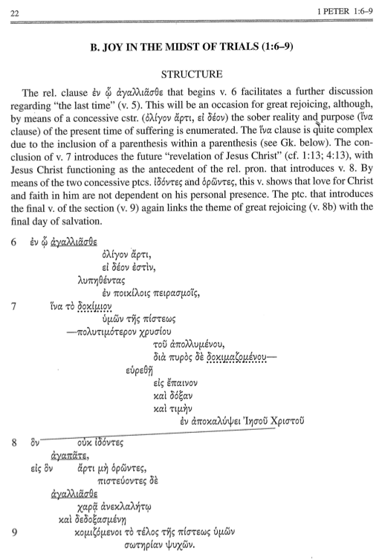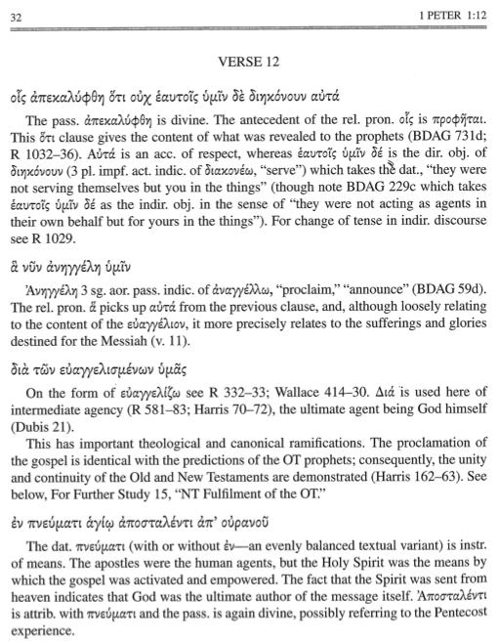
The next section, appropriately called, For Further Study (see Figure 5), highlights theological topics that arise within the passage just considered. For instance, in relation to Colossians 1:1–2, the author highlights five theological areas of interest: apostleship in the New Testament; the ancient letter; the “in Christ” formula; New Testament benedictions; and the Fatherhood of God. Under each of these headings, the author provides resources from dictionaries, books, journals, and other academic resources. In regard to the five topics noted above, the least documented topic had seven resources listed, while the most had fourteen. An additional and much welcome element of the bibliographies is the presence of an asterisk next to the resource that, in the opinion of the author, provides the best general introduction to the topic. There is a noticeable slant towards evangelical literature in the bibliographies.
Figure 5: For Further Study
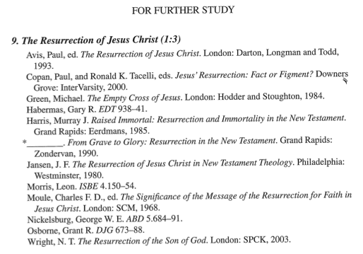
Concluding each text selection are homiletical suggestions (see Figure 6) designed to provide “raw materials for sermon preparation.” The first outline presented for each section is described by Harris as “an outline of the whole paragraph, and is, in fact, more exegetical than homiletical.” Other outlines, however, may be given according to three types of sermons: exegetical, textual, or topical. The exegetical differ from the textual by considering a longer section of text, but both focus attention on one central passage. The topical sermon outline may highlight something within the text that is also present elsewhere in the biblical corpus, which when considered together may provide sufficient material for a sermon. Due to the nature of preaching narrative material, Thompson indicates that his homiletical suggestions in the Luke volume are of the “more ‘homiletical’ type rather than the additional ‘exegetical’ outline type.” Further, he highlights that his homiletical suggestions may span over large groups of verses, noting that he hopes doing so “will encourage attention to the flow of thought in broader literary units and help facilitate progress in preaching through Luke’s Gospel.”
Figure 6: Homiletical Suggestions
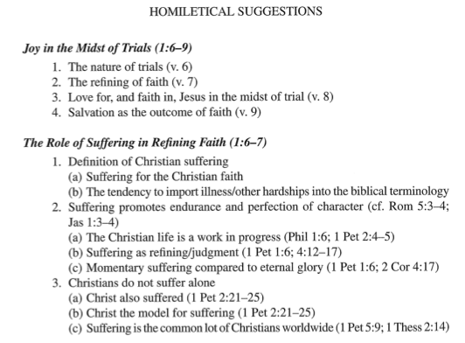
After every verse section has been examined, the volumes end with helpful concluding material. First, a comprehensive Exegetical Outline is offered. For the majority of the volumes, this outline is the culmination of the first homiletical suggestion from each text selection. Harris’ original volume also included the author’s translation as well as an expanded paraphrase. Unfortunately, later volumes dropped these sections. Added to the later books, however, are grammar and scripture indexes. The grammar index offers a guide to finding grammatical forms within the book. For instance, if one is interested in finding where rhetorical questions are used in 1 Peter, this index highlights the page numbers within the volume (not the location in the Greek text) where rhetorical questions are discussed. The Scripture Index is also quite helpful, but is not designed to show where the Greek text cites the Old Testament, as one might assume. Instead, it shows where Old Testament passages are mentioned within the handbook.

Critique
This series is designed for a broad audience and thus embraces a wider scope than the Exegetical Summary series considered earlier. Undoubtedly, the variety and breadth of notes on grammar, syntax, and lexical issues accomplishes the purpose of bridging the gap between grammars and the available language tools. Further, as a professor, I would be quite comfortable assigning books in the series as a preparatory aid to classroom engagement, helping prepare the students for the topics we will cover in class. Finally, I have little doubt pastors will be interested in considering the homiletical suggestions, even if I think few will simply borrow such outlines.
The introduction sections to each volume may appear unnecessary, but they are helpful. Clearly, the introduction sections are not comprehensive, nor are they designed to be. Nevertheless, it is helpful to have a sense of the author’s understanding of introductory issues such as author, purpose, and date. There are times, though admittedly few, when such considerations impact the analysis of the Greek text. On the other hand, I think the introduction sections could be more helpful by including a standardized section that highlights the Greek style of the book under consideration. For instance, the volume on 1 Peter does this by including a lengthy section on imperatives and what are sometimes called imperatival participles. Such a section is helpful, because 1 Peter is the locus for the argument concerning the existence of such a participial use. Other volumes include similar sections, but not all volumes do.
As noted above, the homiletical suggestions may prove useful to pastors. Nevertheless, some volumes will be more useful than others. For some authors, the homiletical outlines are mostly limited to exegetical outlines of the passage just considered. While these may produce a usable homiletical outline, they often do not. On the other hand, other authors give considerable effort to how the section may be preached, not only providing an exegetical outline, but providing two or three different ways of addressing the passage according to the needs of the audience. Thus, each volume should be weighed separately concerning the usefulness of the homiletical suggestion section.
It is surprising that the series chose to move away from including the author’s translation of the text. Incorporating such a translation could help students grasp how the just discussed grammatical considerations would apply to the translation of the text. Additionally, including the author’s translation would make a useful pedagogical tool if offered at the end of the volume. For instance, a student could translate the text according to the grammatical discussion given in the section and then compare his translation with the author’s translation. Differences in translation would undoubtedly lead the student to further reflect on the passage at hand.
Unfortunately, the series is not as accessible as some others. First, despite its early beginnings, only ten New Testament books have been covered in the series so far. Nevertheless, the pace of publication has been encouraging in recent years. Second, the series is not available in Logos, Accordance, or BibleWorks. It is, however, available in WORDsearch, a less known Bible program. Since WORDsearch is owned by LifeWay, the same company who owns the publisher, Broadman and Holman, it may be considered a conflict of interest to allow the series to be offered in rival programs.
There is some expected variance between volumes. The following chart (see Figure 7) tracks the level of detail of each volume by comparing the number of Greek words in each Greek text compared with the number of pages devoted to that Greek text. The lower the number of Greek words per page, the more detailed the volume. For instance, the volume on Philippians averages 5.84 Greek words considered on each page, while the volume on 1 Peter averages 8.96 Greek words per page. These two Greek texts are of nearly equal size, but the level of detail in the Philippians volume is considerably greater. As the chart reveals, longer volumes are associated with lesser consideration of detail.
Figure 7: Greek Words Considered per Page in EGGNT
 | Greek Word Count | Pages in Volume | Greek Words per Page
Philippians | 1,629 | 279 | 5.84
Colossians & Philemon | 1,917 | 248 | 7.73
James | 1,742 | 200 | 8.71
1 Peter | 1,684 | 188 | 8.96
Ephesians | 2,422 | 226 | 10.72
Romans | 7,111 | 400 | 17.78
John | 15,635 | 348 | 44.93
Luke | 19,482 | 381 | 51.13
Matthew | 18,345 | 354 | 51.82

In conclusion, the greatest strength of the EGGNT series is its breadth. Every reader will find something important. It is the only series to include homiletical suggestions, helping the readers transition from exegetical reflection to homiletical practice. It is also the only series to include substantive bibliographies on theological issues encountered in the text. These prove valuable for the pastor, student, or researcher who desires to dig deeper into the theological meaning of the passage. The structural outlines are also unique, and even if one prefers a different method for diagramming Greek sentences, much can be learned through the visual layout.

Baylor Handbooks on the Greek New Testament
The BHGNT series calls itself a prequel to biblical commentary, highlighting that the books make “little attempt to expound on the theological meaning or significance of the document under consideration.” Instead, the focus of each volume is explicitly textual: “BHGNT is designed to guide new readers and seasoned scholars alike through the intricacies of the Greek text.” In fact, Mark Dubis notes that one of the aims of the series is “not only to apply traditional syntactical analysis to the text of the New Testament but also to acquaint readers with more recent developments among grammarians and linguists.” Stated more broadly the editor notes that “BHGNT [aims] both to help move linguistic insights into the mainstream of New Testament reference works and, at the same time, to help weed out some of the myths about the Greek language that continue to appear in both scholarly and popular treatments of the New Testament.”
It is clear that students and scholars are the intended audience of the series. The guides are not designed to give an overview of the position of various scholars; instead, each volume develops the view of the assigned author, often without substantial engagement with other resources. In this way, the volumes mimic a classroom experience, where a seasoned guide leads a class through the Greek text. In fact, this appears to be precisely what is intended by the series, for the editor notes that while the volumes will be useful to those still in formal classroom settings, they are also designed to aid those who no longer have access to such settings.
While the focus of the series is to “help advance our understanding of the Greek New Testament,” the editor also indicates the series is designed to “be used to further equip the saints for the work of ministry, and fan into flame a love for the Greek New Testament among a new generation of students and scholars.”

Book Structure
Each volume begins with the standard Series Introduction. Written by the general editors, Martin M. Curly (2003–2015) and Lidija Novakovik (2016–present), this section orientates the reader to the purpose, layout, and design of the book. Two notable positions are stated as foundations in the series. First, while the editors note that authors will “vary in their theoretical approaches they bring to the text,” they state that there is agreement by all authors in the series on deponency. That this issue is significant to the series can be seen in the length of the section dedicated to it (about 40% of the series introduction). The general position is that deponency is an improper category in Greek, and that many verbs previously labeled deponent are actually middles. The second notable decision in the introduction concerns the labels used of verb tenses. While many grammars and commentaries speak of the “ingressive,” “epistolary,” or “gnomic” function of aorist verbs, this series argues that labeling these as functions “typically stems not from a careful analysis of Greek syntax but rather from grappling with the challenges of translating Greek verbs into English.” Thus, while traditional terminology has been preserved for most of the book, in these two areas, this series is seeking to forge a new, more educated path forward.
After the series introduction comes the author’s Introduction, which is primarily focused on introducing the reader to the Greek text of the book under consideration. The volumes in this series dramatically differ in this section. A few volumes include general introduction matters (authorship, purpose, etc.), but most skip over these. Other volumes discuss discourse analysis at length, while still others focus on word order. Some develop firm aspectual distinctions, drawing out what each aspect communicates, while others do not directly reference aspect. Most of the books, however, include a discussion of the Greek style of the author.
Next, the Greek text itself is considered (see Figure 7). A section of text, roughly corresponding to paragraphed sections, is presented in the author’s English translation based on the grammatical analysis that will be surveyed in that section. Each verse is then given in bold Greek text. Under each verse, selected words or phrases are chosen for consideration. These words and phrases are also in bold and are followed by explanatory notes, highlighting grammatical, lexical, and text-critical issues. Often notes simply highlight the author’s opinion on grammatical function (e.g., objective genitive, predicate nominative, etc.), while others develop in detail the debate over the function of the grammatical feature in that passage (e.g., the significance of οὐ with a participle; Col 2:19). These notes are the heart of the work, and they provide opportunity for the author to show how modern advances in Greek influence one’s interpretation of the text.
Figure 8
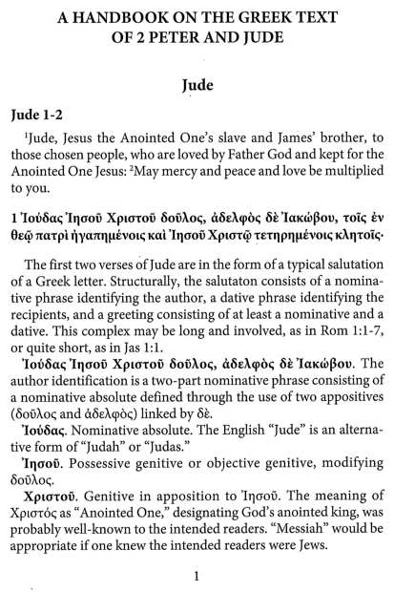
After the text has been fully considered, there is helpful material in the back of the book. First, the Glossary is exceptionally useful, defining technical terms that are used throughout the work. Since the text is designed to introduce readers to advances in Greek, some terminology is not familiar, even if one has been taught with standard Greek grammars (e.g., left dislocation, comparative frame, etc.). The Glossary also provides definitions for terms that a student should already know but may have forgotten (e.g., anarthrous, protasis, etc.). Second, the Bibliography section collects in one place the resources cited throughout the work. Third, the Grammar Index, one of the most helpful elements in the text, identifies where various grammatical features are present in the text. For instance, a reader seeking to study the accusative subject of the infinitive in one of the volumes need only to turn to this index, where each of the clear uses is identified (e.g., Col 2:1; 4:4, 6). This Grammatical Index differs from the EGGNT grammar index in that the latter indicates the page location within the volume, while the former indicates the location within the biblical text. Finally, an Author Index provides a quick guide to finding where people are referenced in the text.

Critique
This series intends to emphasize the intersection between modern advances in the study of Greek and its application to biblical passages. Indeed, the call for modern commentaries to embrace such advances has been often repeated, and many believe it has been unheard. A series like this has the opportunity to highlight those areas where modern advances impact our understanding of the text. And as a “prequel to commentary,” as the editors have labeled the series, these books may serve as helpful guides for future commentary series.
The multitude of exegetical notes throughout the volume is the key strength of the work. Frequent mention is made of linguistic theory, aspectual distinctions, and prominence expressed through word order. In other words, these notes accomplish the purpose of helping a reader see how linguistically sound modern Greek advances apply to the text of Scripture. Those interested in the application of discourse analysis to the Greek New Testament will find a handy friend in many of these volumes. Stated differently, these books provide a window through which the reader can watch a Greek specialist apply his linguistic theory to the text of the New Testament. For example, this series gives rich opportunity for readers of Campbell’s work on aspect to observe him apply the theory to two New Testament works.
The substantive introduction sections to each text are one of the chief highlights of the work. By orienting the reader to the idiolect of the Greek author, these introductions provide a solid starting point for scholars and students to engage the text. Further, some of the introduction sections could stand on their own as independent articles addressing modern Greek advances. For example, Fredrick Long’s lengthy introduction to 2 Corinthians provides a valuable primer for discourse analysis. And Campbell’s volume on Colossians and Philemon addresses verbal aspect at length, charting the way semantic and pragmatic features combine to produce implicature.
Imbalance in the series introductions makes them less useful over the whole series, however. The unevenness in presentation can be seen by a quick glance at the length of the introductions, ranging from three pages (1 Peter) to twenty-seven pages (2 Corinthians). Clearly, the editors have given great freedom to the individual authors of the volumes to produce their assigned volume with individual emphasis. There are advantages to this approach, and the volumes certainly demonstrate those strengths. Nevertheless, it would have been helpful for the editors to ask the contributors to answer a few key questions, helping the reader orient where the author stands on some of the more controversial elements of modern advances in Greek, such as aspect, discourse analysis, and word order. As it currently stands, some of the volumes explain the author’s stance on these issues while others do not.
Another benefit to the series concerns the index of grammatical phenomena. Like the indexes in the EGGNT series, these also prove helpful for finding grammatical features within the text. The index is made more useful because the authors were asked to take a conservative stance, including only those occurrences where the author was confident the feature was present. The editors rightly highlight that such an index can be used by “students of Greek wanting to study a particular construction more carefully or Greek instructors needing to develop illustrations, exercises, or exams.”
As with the other series, there is a noticeable imbalance between volumes here as well. A statistical survey of the Greek words considered on each page confirms what is suspected at first glance; some volumes go into greater detail than others. The following chart (Figure 8), shows that some volumes are substantially more detailed than others. For instance, while the volume on 1 Peter digs deeply, covering only 9.5 Greek words per printed page, the volume on Colossians and Philemon considers more than double that amount per page (20.18). The result is that there is much more consideration of the text in the 1 Peter volume than there is in the Colossians and Philemon volume. And while literary genre certainly influences some of the variance in the chart, the differences between similar works highlights the degree of difference among the volumes.
Figure 9: Greek Words Considered per Page in BHGNT
 | Greek Word Count | Pages in Volume | Greek Words per Page
1 Peter | 1,684 | 177 | 9.53
Pastoral Letters | 3,488 | 287 | 12.15
2 Peter & Jude | 1,560 | 112 | 13.92
Ephesians | 2,422 | 171 | 14.16
Galatians | 2,230 | 147 | 15.17
1–3 John | 2,605 | 168 | 15.50
1 Corinthians | 6,830 | 434 | 15.74
James | 1,742 | 108 | 16.13
2 Corinthians | 4,477 | 259 | 17.09
Colossians & Philemon | 1,917 | 95 | 20.18
Mark | 11,304 | 508 | 22.25
Luke | 19,482 | 763 | 25.53
Revelation | 9,851 | 314 | 31.37
Acts | 18,450 | 548 | 33.66

Another criticism is both visual and tactile. The volumes produced before 2013 are ¾ of an inch shorter and ¼ inch wider than the volumes produced after that point. And even the new height and width (5¼ x 8) is noticeably smaller than the ES series (5¾ x 8¾) or the BHGNT series (6 x 9). Their small size makes them awkward to handle, especially the more substantial volumes (e.g., the 802 page Luke volume). Further, even the letter spacing and coloration on the spine of the books are inconsistent, making a collection on a shelf unpleasing to the eye. A second edition of the earlier volumes could remedy some of this concern.
This series is more developed than EGGNT but not as developed as the ES series. Sixteen volumes have been produced to date, with only Matthew, John, Philippians, 1 and 2 Thessalonians, and Hebrews still to be produced. As for Bible software, Logos sells the series, but only eight of the sixteen printed volumes are presently available in the software. No other software packages currently offer the series.
In conclusion, the BHGNT series uniquely pushes advances in Greek studies into application to biblical texts. And while many of the grammatical comments are similar to those in the EGGNT series, there is a noticeable emphasis on elements of discourse analysis (aspectual prominence, word order, etc.), which are relatively rare in the EGGNT series. And while one may criticize the series for too little interaction with other resources, the goal of this series is not to be a comprehensive or even dogmatic. Instead, the authors are frequently satisfied to offer their interpretation without defense, directing the reader’s attention instead to the way modern Greek advances influence the interpretation of the text.

Conclusion
Having surveyed each of the series, we can now compare them. We will primarily do so by considering who would most benefit from each series. First, translators would most benefit from the ES series. This is unsurprising since the series is designed for translators. The questions included in the series help translators focus their attention to those areas of controversy, and to see at a glance which translations and commentaries took which position. Having this information in one place is an invaluable resource, for it saves significant time by directing the reader to the resources where he can find arguments for specific positions. The second most helpful series for translators is BHGNT, because it seeks to move modern Greek advances into the mainstream. Put differently, the translator who already has ES and multiple exegetical commentaries, would benefit most by seeing what BHGNT uniquely expresses.
Pastors will find the EGGNT series most useful. From its first volume, much attention has been directed to making exegetical observations applicable through homiletical suggestions. The other series considered in this review were not specifically designed with pastors in mind, though they will prove useful. For instance, the BHGNT series may highlight where emphasis ought to be given in a sermon by means of showing where the author of the Greek text placed emphasis as revealed by discourse analysis. Further, the discourse unit section in ES series may be useful to the pastor when he is deciding how to divide the biblical text into appropriate preaching segments.
Students will benefit most from BHGNT or EGGNT, depending on their knowledge of Greek. BHGNT is more useful to the advanced student who already knows the exegetical options. This is because the series often makes a decision on a function without discussing the other options. On the other hand, EGGNT is much more detailed, considering multiple options before deciding. Both series assume familiarity with Greek, but BHGNT assumes a greater knowledge, and seeks to push that knowledge further by introducing concepts that are not generally included in a second-year Greek course. EGGNT, on the other hand, only occasionally advances beyond what is learned in those formative years, choosing instead to illustrate what the student should already know. In the words of the editors, EGGNT is designed as a bridge between grammar tools and the Greek text. In comparison, it seems that BHGNT is designed as a bridge between modern Greek advances and the Greek text.
Two other elements make the EGGNT series attractive for students. First, the rich theological bibliographies provide a spring-board for further investigation. Second, the series considers the Greek text phrase by phrase, highlighting the connection between the phrases. This differs from the BHGNT series which considers the text verse by verse. The latter series may show the broader connections more clearly (especially through discourse analysis), but the visualization of the relationships through diagrams provided by EGGNT is exceptionally useful.
Students may also find the ES helpful. Because the series is question-driven, it helps novice students learn the appropriate questions to ask of a text. Having read a few volumes, a student will learn to automatically ask the right questions when confronted with a grammatical form that is capable of being understood in more than one way. Further, more advanced students will find the breadth of secondary reference material helpful.
A final consideration concerns Bible software. The ability of Bible software to connect the Greek text to many resources makes grammatical tools like these considerably more useful. Unfortunately, Accordance and Bible Works do not sell any of the series considered in this review. As for Logos, it sells both the ES series and the BHGNT series, but the latter lacks some of the volumes available in print. EGGNT is, unfortunately, only available through a little-known software program.
In conclusion, each of the series has a primary audience and purpose in view. Consequently, readers will find each excels in different ways, and there are plenty of reasons to collect them all. Thanks be to God who has blessed His people with an abundance of resources to study His Word.
Figure 10: Charting the Comparisons
 | Strengths | Weaknesses | Unique | Most Useful for
ES | - Shows all significant exegetical options  - Directs to many resources  - Teaches what questions a student should be asking  - Available in Logos  - Direct focus on discourse units | - 2nd editions are not up to date.  - The resources (commentaries and versions) considered are not consistent across the volumes. | - Question oriented  - Discusses discourse units  - Reference guide | - Translators  - Students  - Pastors
EGGNT | - Includes homiletical suggestions  - Rich theological bibliographies  - Grammar index  - Structural outlines that visualize grammatical function | - Inconsistency in scope of homiletical outlines  - Few volumes produced to date  - Not available in major Bible programs | - Intentionally pastoral  - Theological bibliographies  - Visual structure | - Pastors  - Students  - Translators
BHGNT | - Applies modern advances in Greek to biblical passages  - In-depth introductions  - Grammar index  - Available in Logos | - Imbalance between volumes  - Little interaction with other sources  - Odd book dimensions | - Focused on advancing Greek  - Focus on Discourse analysis  - Focus on word order | - Students  - Pastors  - Translators

Murray J. Harris, Exegetical Guide to the Greek New Testament: Colossians and Philemon (Grand Rapids: William B. Eerdmans, 1991).
Murray J. Harris, Exegetical Guide to the Greek New Testament: Colossians and Philemon (Nashville: B&H Academic, 2010).
Their website description of the series notes that it is “Helpful for students and translators with beginning to advanced exegetical skills to produce a meaningful translation.” “Exegetical Summary Series,” SIL International, accessed October 26, 2017, https://www.sil.org/resources/publications/ess.
David Abernathy, An Exegetical Summary of 1 Peter, 2nd ed. (Dallas: SIL International, 2008), 6.
Ibid., 5.
Martha King, An Exegetical Summary of Colossians, 2nd ed. (Dallas: SIL International, 2008), 11.
Abernathy, An Exegetical Summary of 1 Peter, 5.
Ibid., 31.
Louw Johannes P. and Nida Eugene Albert, Greek-English Lexicon of the New Testament: Based on Semantic Domains, 2nd ed. (New York: United Bible Societies, 1996); Walter Bauer et al., A Greek-English Lexicon of the New Testament and Other Early Christian Literature, Second Edition 2nd Edition by Walter Bauer, Gingrich, F. Wilbur (1979) Hardcover, 2nd ed. (The University Of Chicago Press, 1979).
In the preface, the editor notes that “Typical questions concern the identity of an implied actor or object of an event word, the antecedent of a pronominal reference, the connection indicated by a relational word, the meaning of a genitive construction, the meaning of figurative language, the function of a rhetorical question, the identification of an ambiguity, and the presence of implied information that is needed to understand the passage correctly.” Abernathy, An Exegetical Summary of 1 Peter, 5–6.
When I was in seminary, my professor, Dr. Albin Huss, required that we use these volumes in our Greek exegesis courses. I found them quite helpful.
Abernathy, An Exegetical Summary of 1 Peter, 6.
Paul J. Achtemeier, 1 Peter: A Commentary on First Peter, Hermeneia (Minneapolis, MN: Fortress Press, 1996); John H. Elliott, 1 Peter: A New Translation with Introduction and Commentary, The Anchor Yale Bible Commentaries (London: Yale University Press, 2001); Karen H. Jobes, 1 Peter, Baker Exegetical Commentaries (Grand Rapids: Baker Academic, 2005); Thomas R. Schreiner, 1, 2 Peter, Jude, vol. 37, New American Commentary (Nashville: B&H Academic, 2003).
Since BDAG, the third edition of the lexicon, differs in many places from BAGD, the second edition, it is not possible for Logos to forward the links to the new lexicon. And since there is a third edition, Logos users can no longer purchase the previous edition. Of course, the best course forward would be an update to the ES series, which in recent volumes has continued to rely on BAGD in spite of the new edition.
Harris, EGGNT: Colossians and Philemon, 29.
Ibid., back cover.
Greg Forbes, Exegetical Guide to the Greek New Testament: 1 Peter (Nashville: B&H Academic, 2014), xvi.
Alan J. Thompson, Exegetical Guide to the Greek New Testament: Luke (Nashville: B&H Academic, 2017), xxxi.
Harris, EGGNT: Colossians and Philemon, 2.
Thompson, EGGNT: Luke, xxx.
Harris, EGGNT: Colossians and Philemon, 15.
Forbes, EGGNT: 1 Peter, 22.
Ibid., 32.
Ibid., 20.
Harris, EGGNT: Colossians and Philemon, 16.
Ibid., 15.
Ibid.
Thompson, EGGNT: Luke, 7.
Ibid.
Forbes, EGGNT: 1 Peter, 28.
Ibid., 4–7.
For instance, the volume on the Gospel of John details unique elements of John’s Greek style (Murray J. Harris, Exegetical Guide to the Greek New Testament: John (Nashville: B&H Academic, 2015), 8–10.), and the volume on Philippians includes a section on Linguistic and Rhetorical Considerations (Joseph H. Hellerman, Exegetical Guide to the Greek New Testament: Philippians (Nashville: B&H Academic, 2015), 4–6.).
In a comparison of the first chapter from the Greek text in each volume, I found the volumes on John, Philippians, and James to include the most suggestions, while the volumes on Luke and Romans included the least number of suggested outlines.
Only pages actually detailing the Greek text are included, so front and back matter have been excluded.
Constantine R. Campbell, Colossians and Philemon: A Handbook on the Greek Text (Waco: Baylor University Press, 2013), ix.
Ibid.
Mark Dubis, 1 Peter: A Handbook on the Greek Text (Waco: Baylor University Press, 2010), xix.
Campbell, BHGNT: Colossians and Philemon, x.
The editor notes that “In order to make the handbooks more user-friendly, authors have only selectively interacted with secondary literature.” Ibid., ix.
Ibid., ix–x.
Ibid., xiii.
Ibid., xi.
Timothy A. Brookins and Bruce W. Longenecker, 1 Corinthians 1-9: A Handbook on the Greek Text (Waco: Baylor University Press, 2016), vii.
For instance, the volumes on Acts, 2 Corinthians, Galatians, Colossians and Philippians, and 2 Peter and Jude include general introduction elements, while the majority of the series does not.
For example, see the volume on 2 Corinthians, where the majority of the twenty-seven-page introduction is devoted to understanding discourse analysis.
See the introduction on Luke
Campbell’s introduction develops aspect at great length. (Campbell, BHGNT: Colossians and Philemon, xxi–xxvii.)
Peter H. Davids, 2 Peter and Jude: A Handbook on the Greek Text (Waco: Baylor University Press, 2011), 1.
Further, Campbell has also written extensively on the in Christ language of Scripture, one of the themes of Colossians (Campbell, BHGNT: Colossians and Philemon.).
Fredrick J. Long, 2 Corinthians: A Handbook on the Greek Text (Waco: Baylor University Press, 2015), xvii–xliii.
Campbell, BHGNT: Colossians and Philemon, xix–xxix.
A quick way of determining the emphasis of each volume is to briefly examine the material discussed in the introduction and the words defined in the glossary. In regard to the former, authors generally discuss the topics they wish to examine in detail within the volume. As for the latter, some volumes contain dense glossaries filled with technical terms related to discourse analysis, while others have much slimmer glossaries. Clearly, the former is much more likely to focus on the details of discourse analysis than the latter.
As noted above, if one is interested in the function of discourse analysis in a text, that is a dominant focus of Fredrick Long in the volume on 2 Corinthians (Long, BHGNT: 2 Corinthians.). Aspect, on the other hand, is a unique focus of Campbell’s work on Colossians and Philemon (Campbell, BHGNT: Colossians and Philemon.).
Brookins and Longenecker, BHGNT: 1 Corinthians 1-9, vi.
That EGGNT is more detailed than BHGNT may not be evident by the charts provided in this review. For instance, the volumes on 1 Peter come close to each other in terms of Greek words per page (9.53 and 8.96 respectively), but two things should be kept in mind. First, the pages in the EGGNT series are substantially larger than those in the BHGNT series. Second, the format of the books makes EGGNT denser than BHGNT. Thus, while nearly the same number of pages are present in each volume on 1 Peter, the amount of text devoted to each is substantially different. On the other hand, the charts reveal that longer works (e.g., the gospels) are considered in equal or greater depth in the BHGNT series than in the EGGNT series.
The BHGNT series lacks all volumes after 2014, making half their volumes inaccessible within the Logos platform.

